**Cognizant_Digital Nurture 4.0_Deep Skilling**

**Module 10 – Single Page Application framework – React**

**1.Create a React App Named “myfirstreact” to Display a Welcome Message**

**App.js**

import React from 'react';

function App() {

  return (

    <div>

      <h1>Welcome to the first session of React</h1>

    </div>

  );

}

export default App;

**Output:**

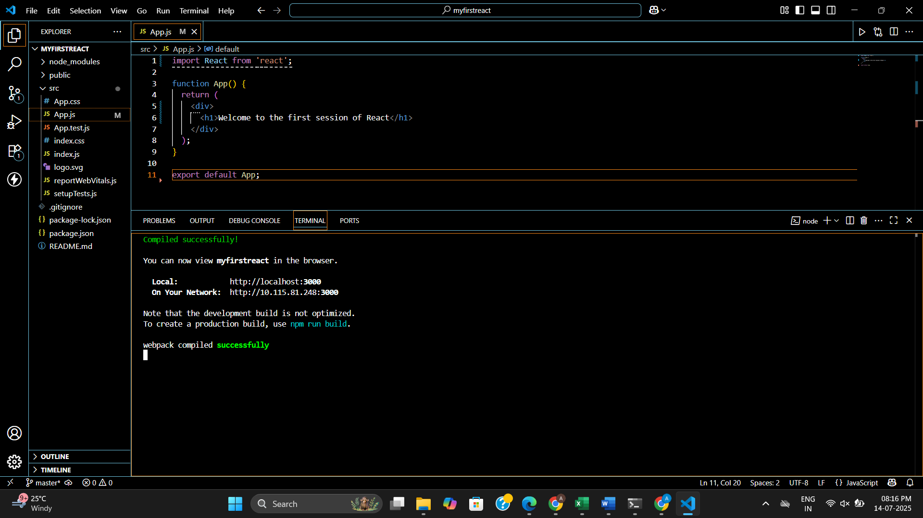

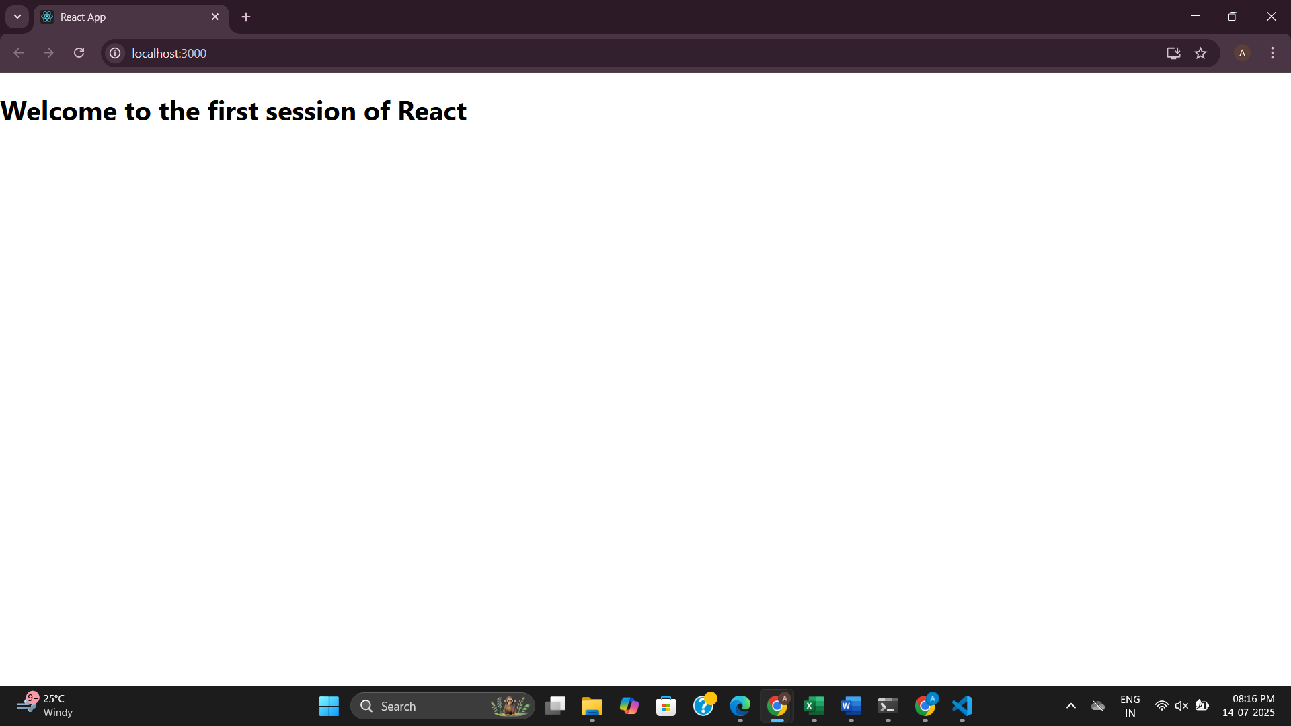

**2.Create a react app for Student Management Portal**

**App.js**

import React from 'react';

import Home from './Component/Home';

import About from './Component/About';

import Contact from './Component/Contact';

function App() {

  return (

    <div className="App">

      <Home />

      <About />

      <Contact />

    </div>

  );

}

export default App;

**Home.js**

import React, { Component } from 'react';

class Home extends Component {

  render() {

    return (

      <div>

        <h2><center>Welcome to the Home page of Student Management Portal</center></h2>

      </div>

    );

  }

}

export default Home;

**About.js**

import React, { Component } from 'react';

class About extends Component {

  render() {

    return (

      <div>

        <h2><center>Welcome to the About page of the Student Management Portal</center></h2>

      </div>

    );

  }

}

export default About;

**Contact.js**

import React, { Component } from 'react';

class Contact extends Component {

  render() {

    return (

      <div>

        <h2><center>Welcome to the Contact page of the Student Management Portal</center></h2>

      </div>

    );

  }

}

export default Contact;

**Output:**

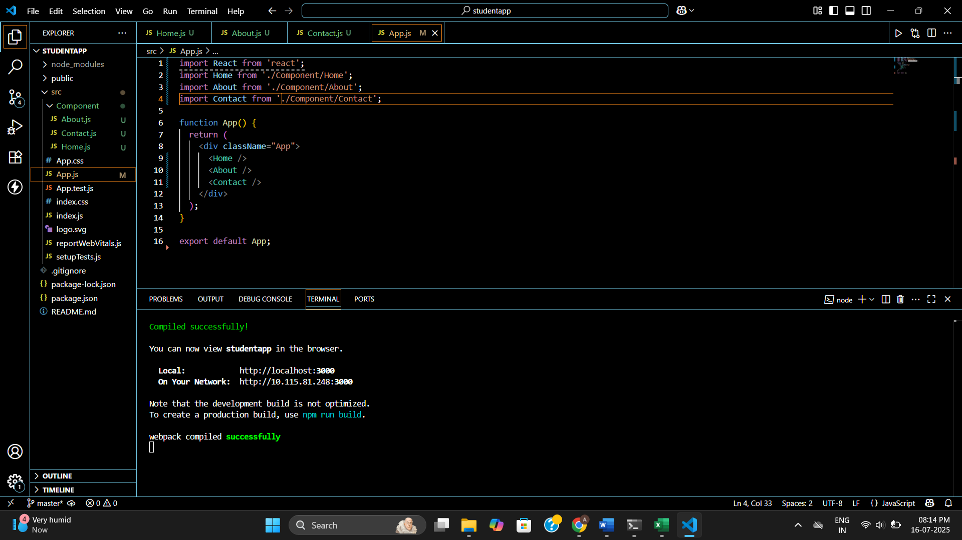

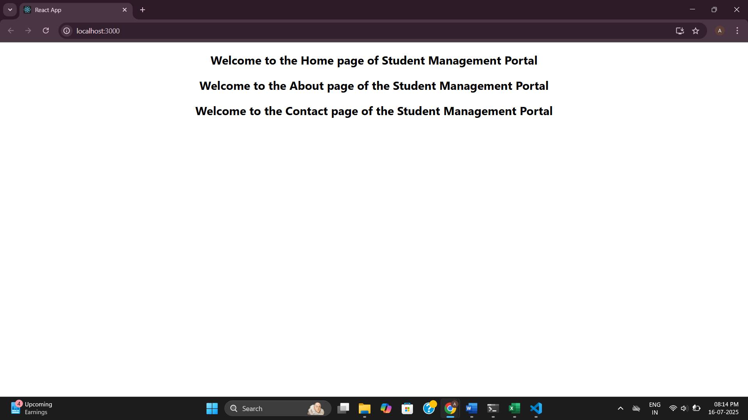

**3.Student Details Display Using React Functional Component**

**CalculateScore.js**

import React from 'react';

import '../Stylesheets/mystyle.css';

function CalculateScore() {

  const name = "Steeve";

  const school = "DNV Public School";

  const total = 284;

  const score = ((total / 300) * 100).toFixed(2); // Example max = 300

  return (

    <div className="details">

      <h1>Student Details:</h1>

      <p><strong className="label blue">Name:</strong> <span className="blue">{name}</span></p>

      <p><strong className="label red">School:</strong> <span className="red">{school}</span></p>

      <p><strong className="label darkred">Total:</strong> <span>{total} Marks</span></p>

      <p><strong className="label green">Score:</strong> <span className="green">{score}%</span></p>

    </div>

  );

}

export default CalculateScore;

**mystyle.css**

.details {

  text-align: center;

  font-family: Arial, sans-serif;

  margin-top: 50px;

}

h1 {

  color: brown;

}

.label {

  font-weight: bold;

}

.red {

  color: red;

}

.blue {

  color: blue;

}

.green {

  color: green;

}

.darkred {

  color: darkred;

}

**App.js**

import React from 'react';

import CalculateScore from './Components/CalculateScore';

function App() {

  return (

    <div className="App">

      <CalculateScore />

    </div>

  );

}

export default App;

**Output:**

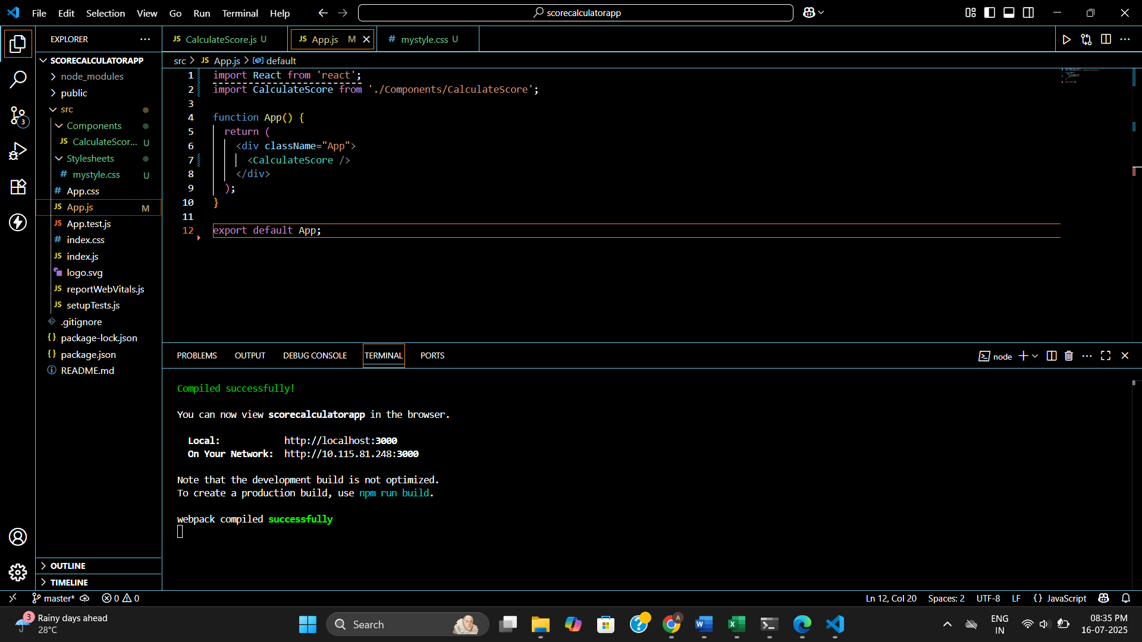

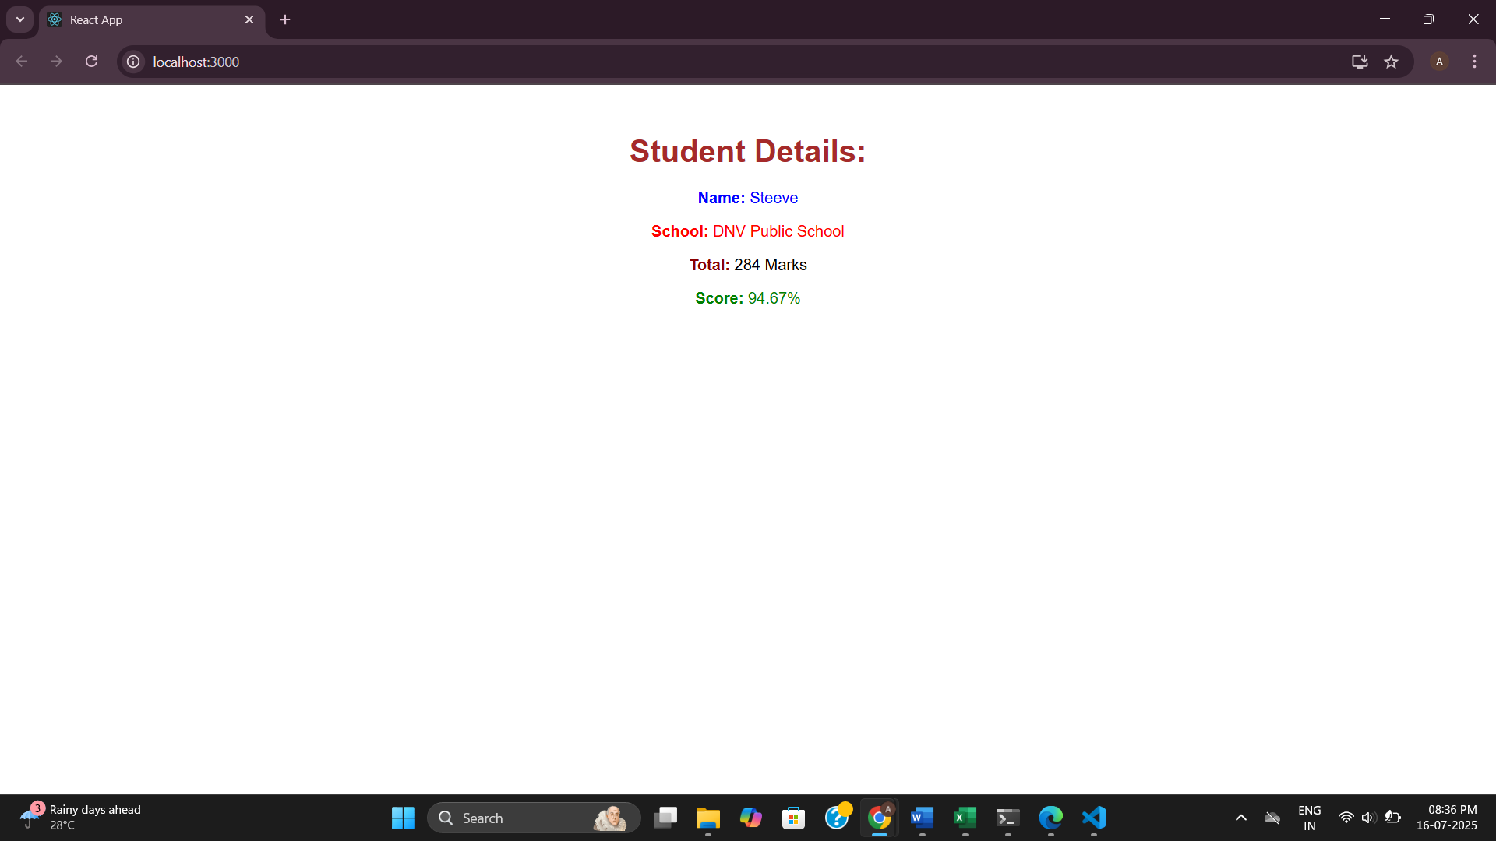

**4.Lifecycle Methods in React – blogapp**

**Post.js**

import React from 'react';

function Post(props) {

  return (

    <div className="post">

      <h3>{props.title}</h3>

      <p>{props.body}</p>

    </div>

  );

}

export default Post;

**Posts.js**

// src/Posts.js

import React, { Component } from 'react';

import Post from './Post';

class Posts extends Component {

  constructor(props) {

    super(props);

    this.state = {

      posts: [],

      hasError: false,

    };

  }

  loadPosts = () => {

    fetch('https://jsonplaceholder.typicode.com/posts')

      .then((response) => response.json())

      .then((data) => {

        this.setState({ posts: data });

      })

      .catch((error) => {

        console.error('Error fetching posts:', error);

        this.setState({ hasError: true });

      });

  };

  componentDidMount() {

    this.loadPosts();

  }

  componentDidCatch(error, info) {

    alert('An error occurred while loading posts.');

    console.error('Error caught in componentDidCatch:', error, info);

    this.setState({ hasError: true });

  }

  render() {

    const { posts, hasError } = this.state;

    if (hasError) {

      return <h2>Something went wrong while displaying posts.</h2>;

    }

    return (

      <div>

        <h2>Blog Posts</h2>

        {posts.slice(0, 10).map((post) => (

          <Post key={post.id} title={post.title} body={post.body} />

        ))}

      </div>

    );

  }

}

export default Posts;

**App.js**

// src/App.js

import React from 'react';

import Posts from './Posts';

function App() {

  return (

    <div className="App">

      <h1>Welcome to BlogApp</h1>

      <Posts />

    </div>

  );

}

export default App;

**Output:**

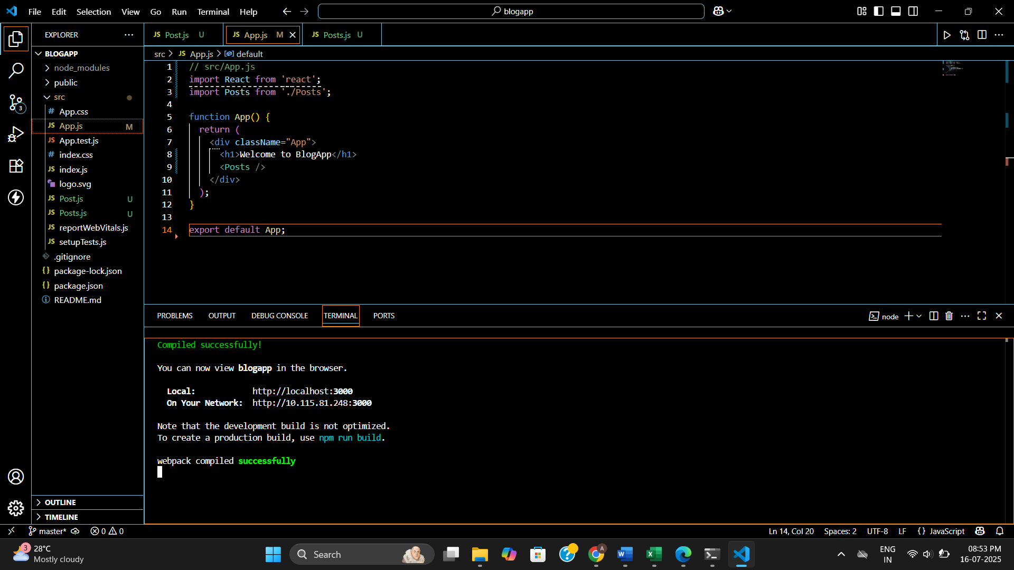

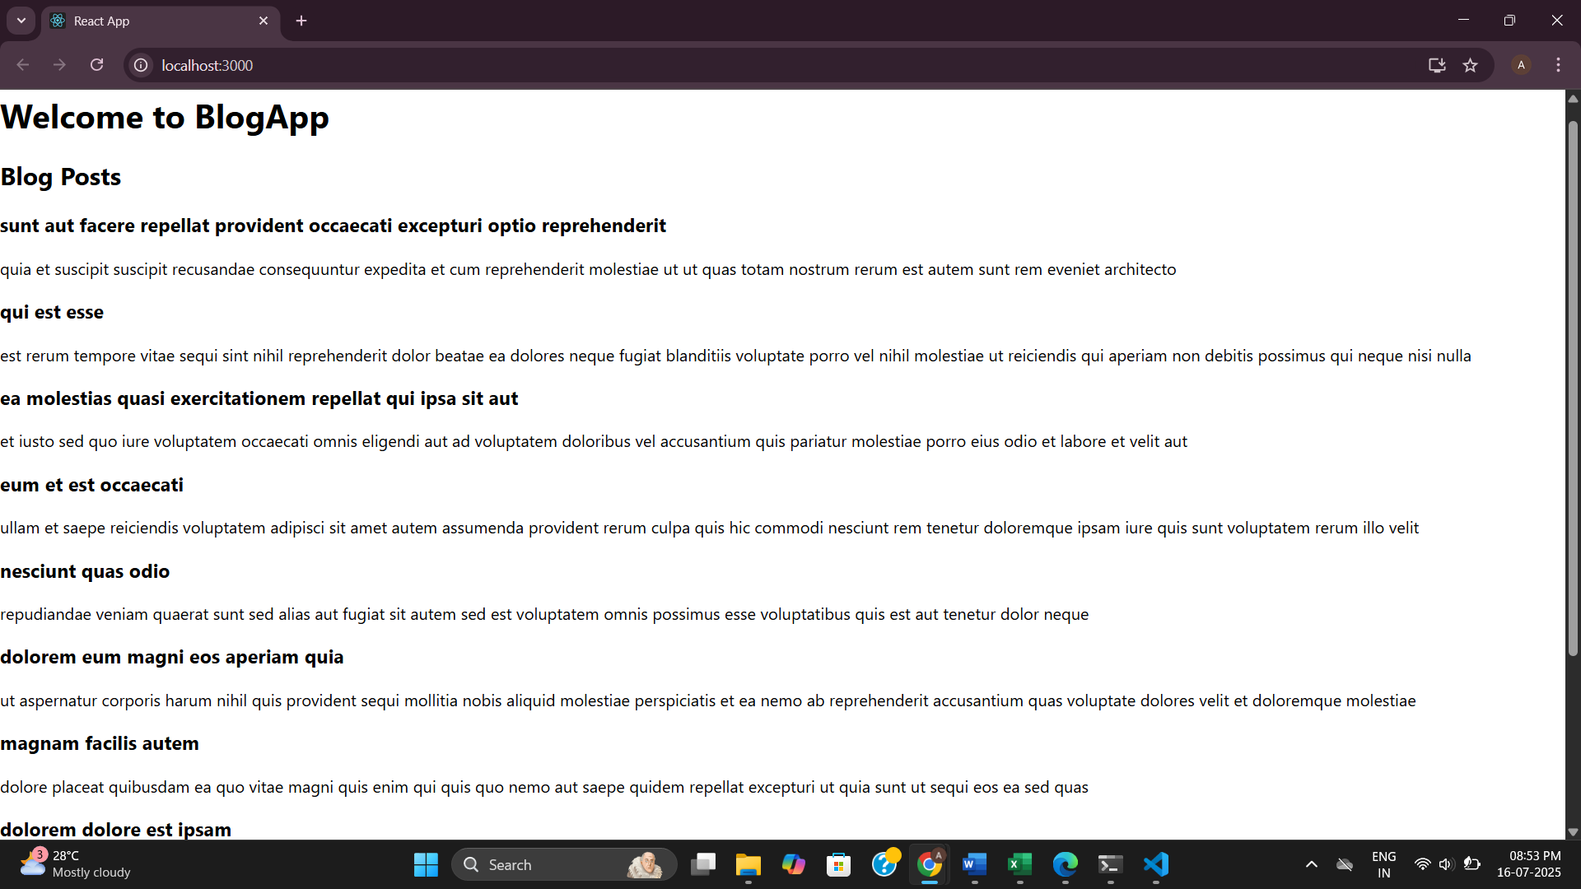

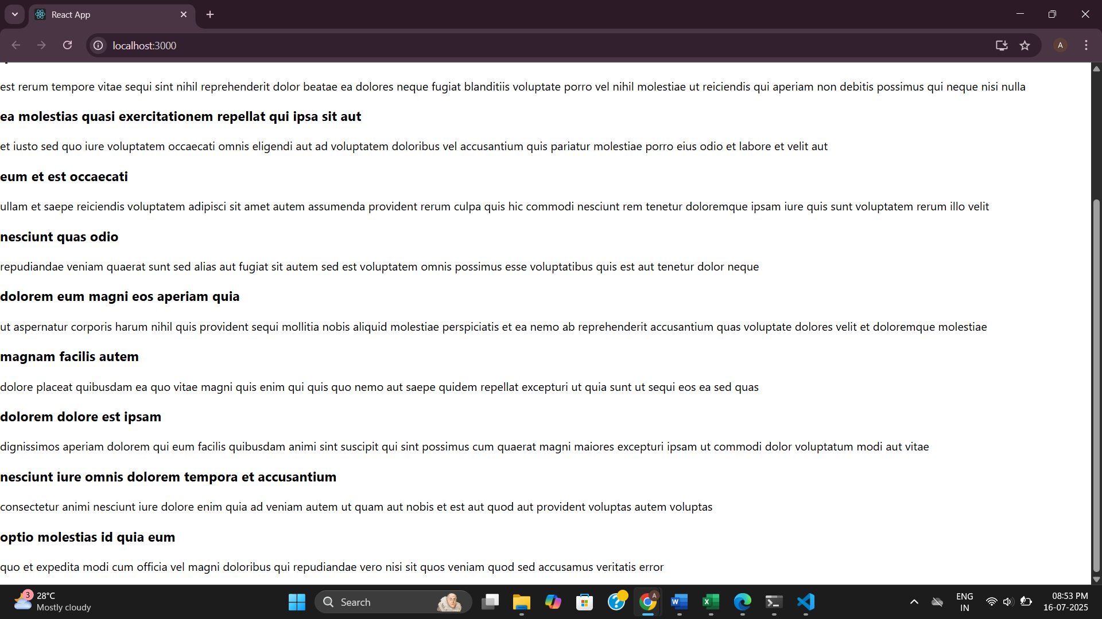

**5.Styling React Components Using CSS Modules and Inline Styles**

**CohortDetails.js**

import React from 'react';

import styles from './CohortDetails.module.css';

function CohortDetails(props) {

  const { cohort } = props;

  const titleStyle = {

    color: cohort.status === 'Ongoing' ? 'green' : 'blue'

  };

  return (

    <div className={styles.box}>

      <h3 style={titleStyle}>{cohort.name}</h3>

      <dl>

        <dt>Started On</dt>

        <dd>{cohort.startDate}</dd>

        <dt>Current Status</dt>

        <dd>{cohort.status}</dd>

        <dt>Coach</dt>

        <dd>{cohort.coach}</dd>

        <dt>Trainer</dt>

        <dd>{cohort.trainer}</dd>

      </dl>

    </div>

  );

}

export default CohortDetails;

**CohortDetails.module.css**

.box {

  width: 300px;

  display: inline-block;

  margin: 10px;

  padding: 10px 20px;

  border: 1px solid black;

  border-radius: 10px;

}

dt {

  font-weight: 500;

}

**App.js**

import React from 'react';

import CohortDetails from './Components/CohortDetails';

function App() {

  const cohorts = [

    {

      name: 'INTADMDF10 - .NET FSD',

      startDate: '22-Feb-2022',

      status: 'Scheduled',

      coach: 'Aathma',

      trainer: 'Jojo Jose'

    },

    {

      name: 'ADM21JF014 - Java FSD',

      startDate: '10-Sep-2021',

      status: 'Ongoing',

      coach: 'Apoorv',

      trainer: 'Elisa Smith'

    },

    {

      name: 'CDBJF21025 - Java FSD',

      startDate: '24-Dec-2021',

      status: 'Ongoing',

      coach: 'Aathma',

      trainer: 'John Doe'

    }

  ];

  return (

    <div>

      <h2>Cohorts Details</h2>

      {cohorts.map((cohort, index) => (

        <CohortDetails key={index} cohort={cohort} />

      ))}

    </div>

  );

}

export default App;

**Output:**

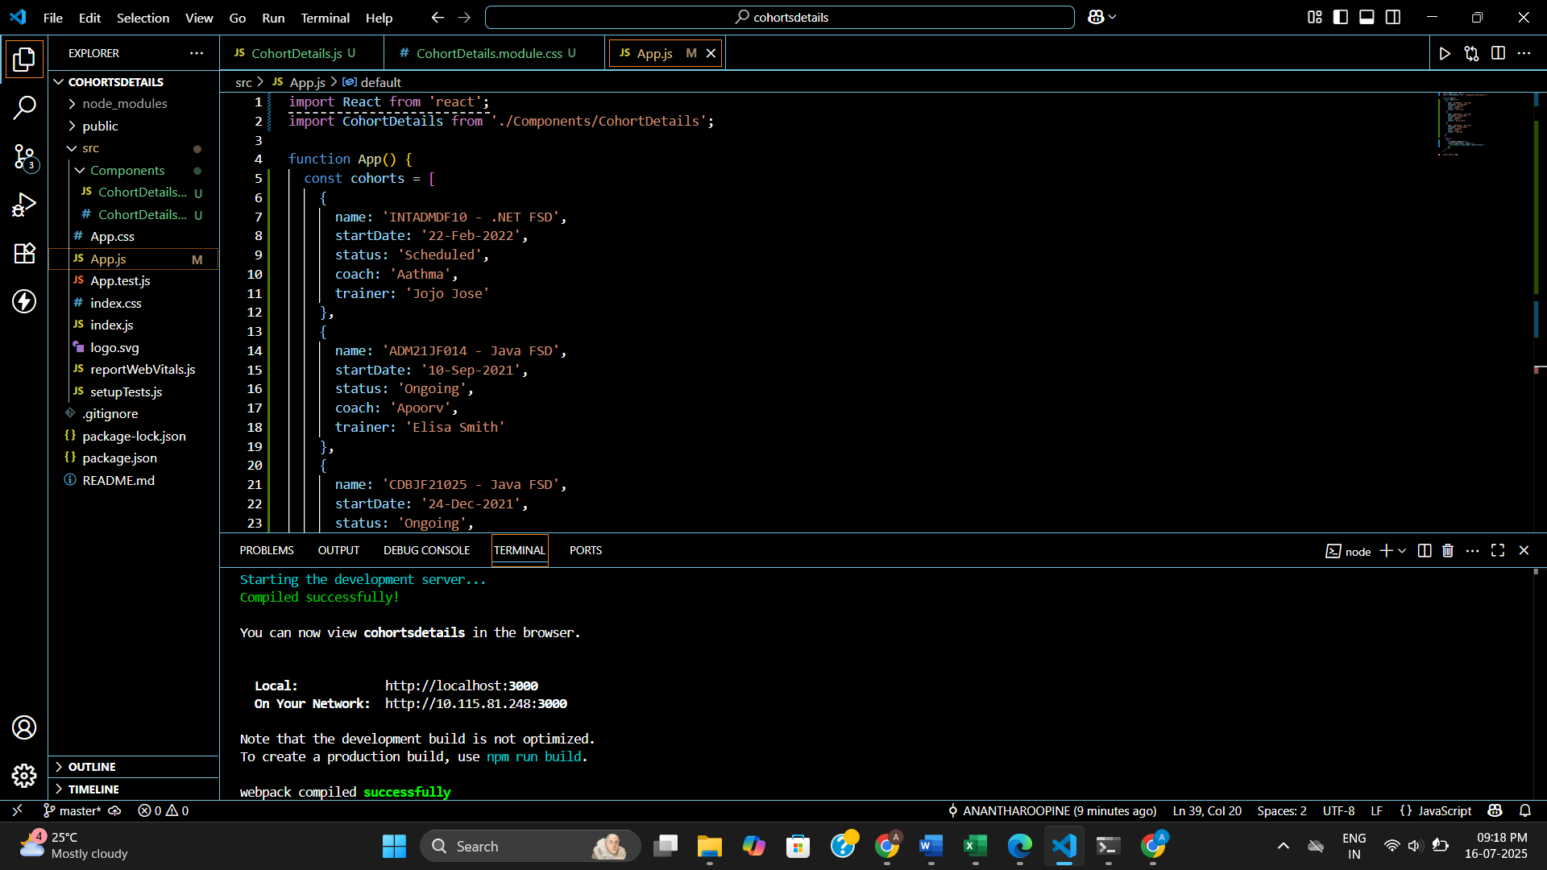

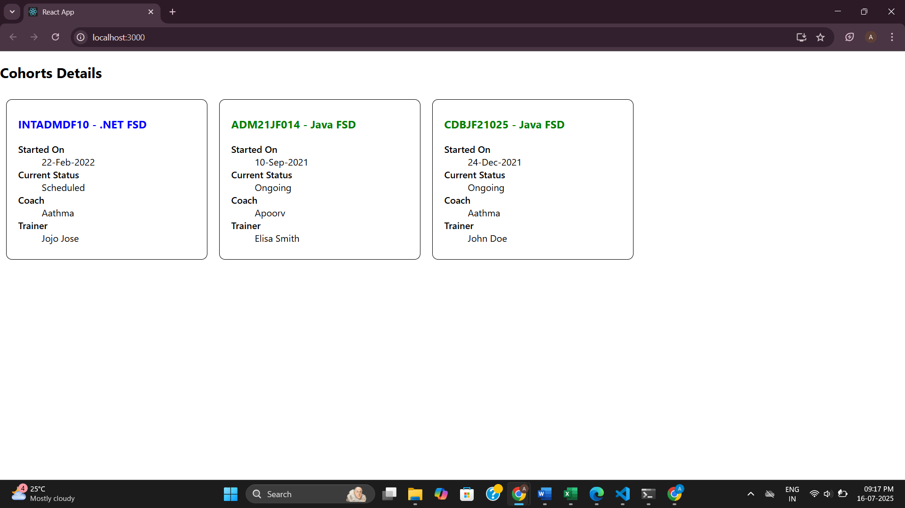

**Additional:**

**6.React Router Based Trainer Directory – My Academy Trainers App**

**trainer.js**

class Trainer {

  constructor(id, name, email, phone, technology, skills) {

    this.id = id;

    this.name = name;

    this.email = email;

    this.phone = phone;

    this.technology = technology;

    this.skills = skills;

  }

}

export default Trainer;

**trainersMock.js**

import Trainer from './trainer';

const trainersMock = [

  new Trainer(

    't-syed8',

    'Syed Khaleelullah',

    'khaleelullah@cognizant.com',

    '97676516962',

    '.NET',

    ['C#', 'SQL Server', 'React', '.NET Core']

  ),

  new Trainer(

    't-jojo',

    'Jojo Jose',

    'jojo@cognizant.com',

    '9897199231',

    'Java',

    ['Java', 'JSP', 'Angular', 'Spring']

  ),

  new Trainer(

    't-elisa',

    'Elisa Jones',

    'elisa@cognizant.com',

    '9871212235',

    'Python',

    ['Python', 'Django', 'Angular']

  )

];

export default trainersMock;

**TrainersList.js**

import React from 'react';

import { Link } from 'react-router-dom';

function TrainersList({ trainers }) {

  return (

    <div>

      <h2>Trainers List</h2>

      <ul>

        {trainers.map((trainer) => (

          <li key={trainer.id}>

            <Link to={`/trainer/${trainer.id}`}>{trainer.name}</Link>

          </li>

        ))}

      </ul>

    </div>

  );

}

export default TrainersList;

**TrainerDetails.js**

import React from 'react';

import { useParams } from 'react-router-dom';

import trainersMock from './trainersMock';

function TrainerDetails() {

  const { id } = useParams();

  const trainer = trainersMock.find((t) => t.id === id);

  if (!trainer) {

    return <p>Trainer not found.</p>;

  }

  return (

    <div>

      <h2>Trainers Details</h2>

      <h3>{trainer.name} ({trainer.technology})</h3>

      <p>{trainer.email}</p>

      <p>{trainer.phone}</p>

      <ul>

        {trainer.skills.map((skill, index) => (

          <li key={index}>{skill}</li>

        ))}

      </ul>

    </div>

  );

}

export default TrainerDetails;

**Home.js**

import React from 'react';

function Home() {

  return (

    <div>

      <h2>Welcome to My Academy Trainers App</h2>

    </div>

  );

}

export default Home;

**App.js**

import React from 'react';

import { BrowserRouter, Routes, Route, Link } from 'react-router-dom';

import Home from './Home';

import TrainersList from './TrainersList';

import TrainerDetails from './TrainerDetails';

import trainersMock from './trainersMock';

function App() {

  return (

    <BrowserRouter>

      <div>

        <h1>My Academy Trainers App</h1>

        <nav>

          <Link to="/">Home</Link> | <Link to="/trainers">Show Trainers</Link>

        </nav>

        <Routes>

          <Route path="/" element={<Home />} />

          <Route path="/trainers" element={<TrainersList trainers={trainersMock} />} />

          <Route path="/trainer/:id" element={<TrainerDetails />} />

        </Routes>

      </div>

    </BrowserRouter>

  );

}

export default App;

**Output:**

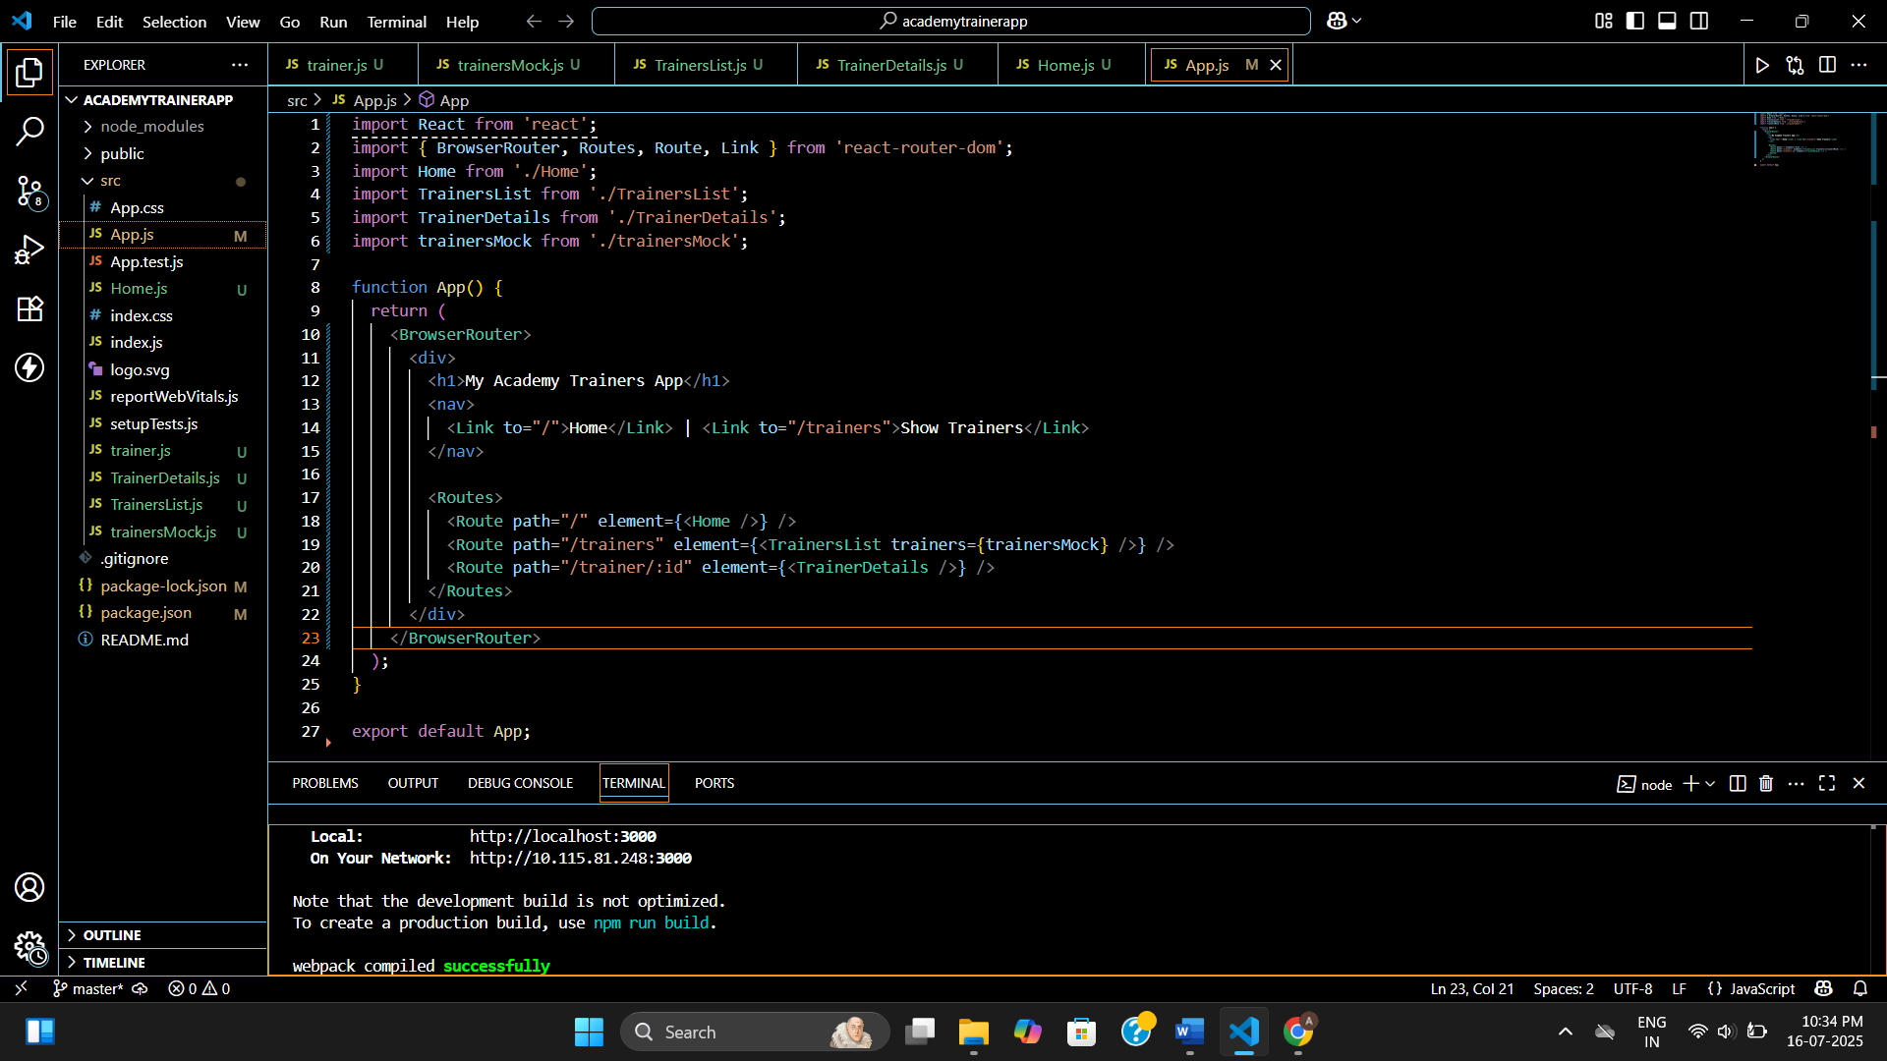

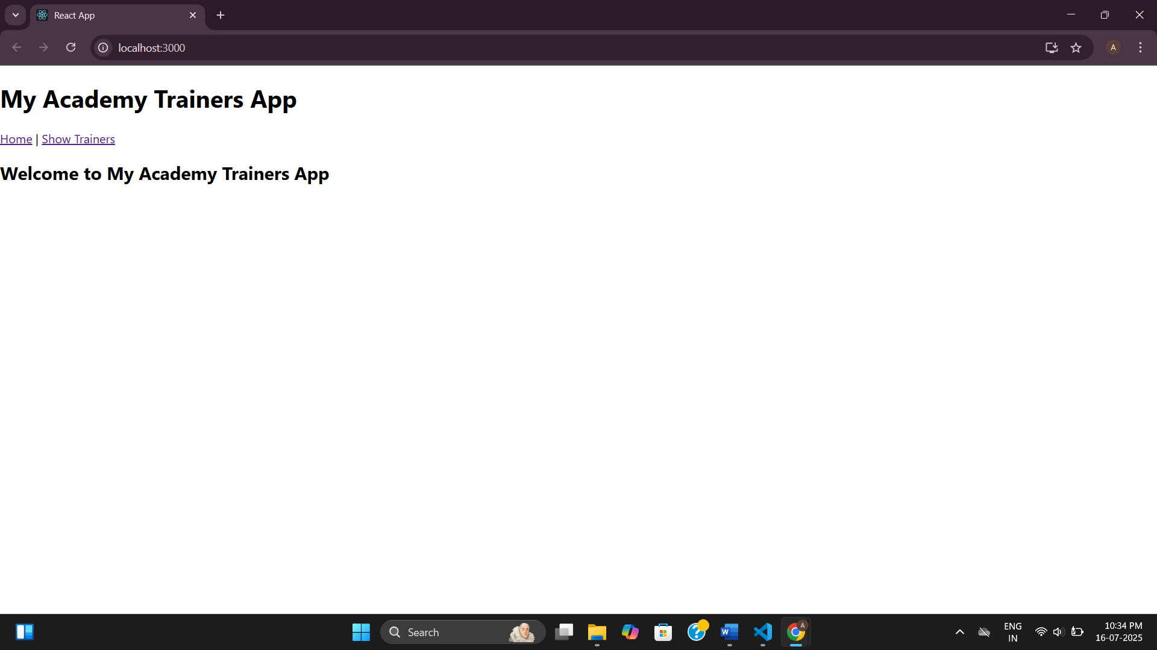

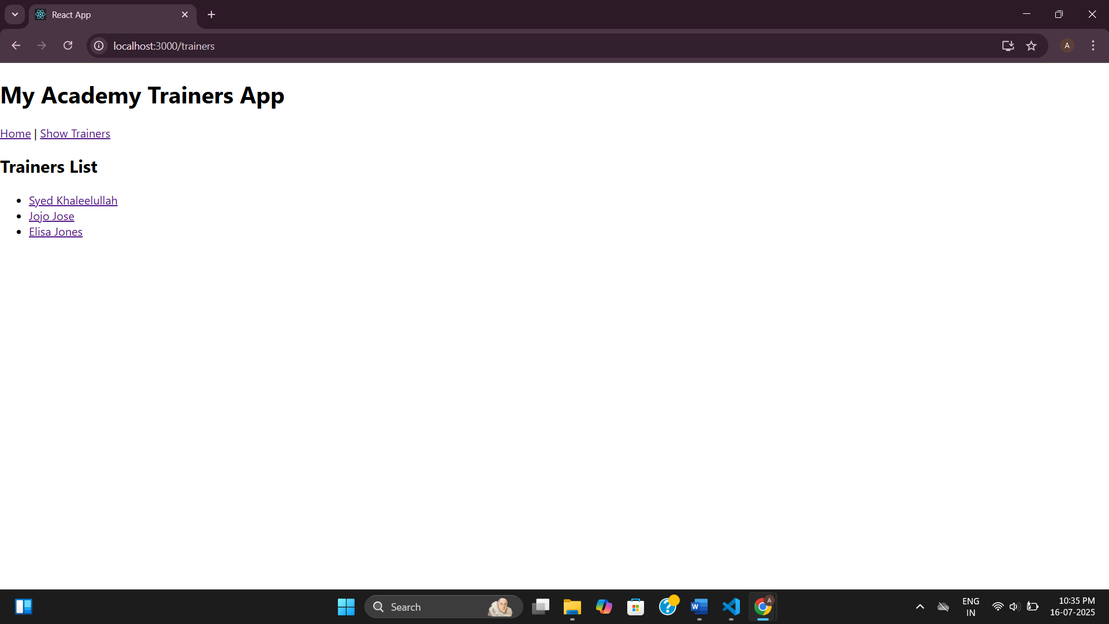

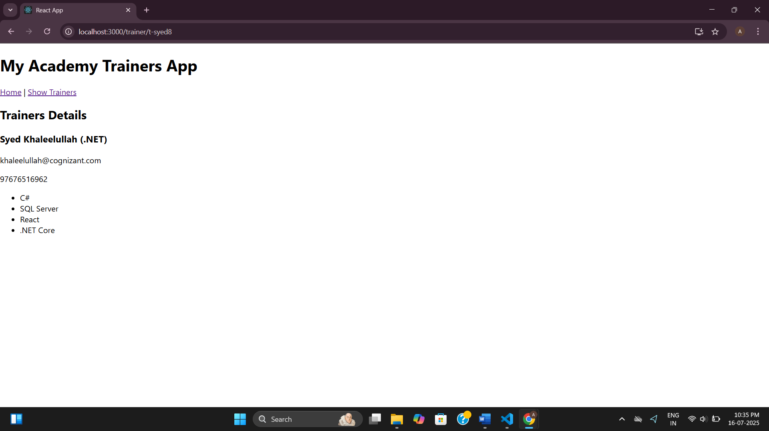

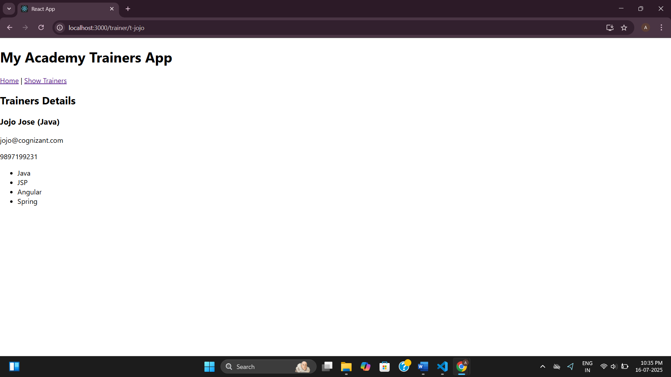

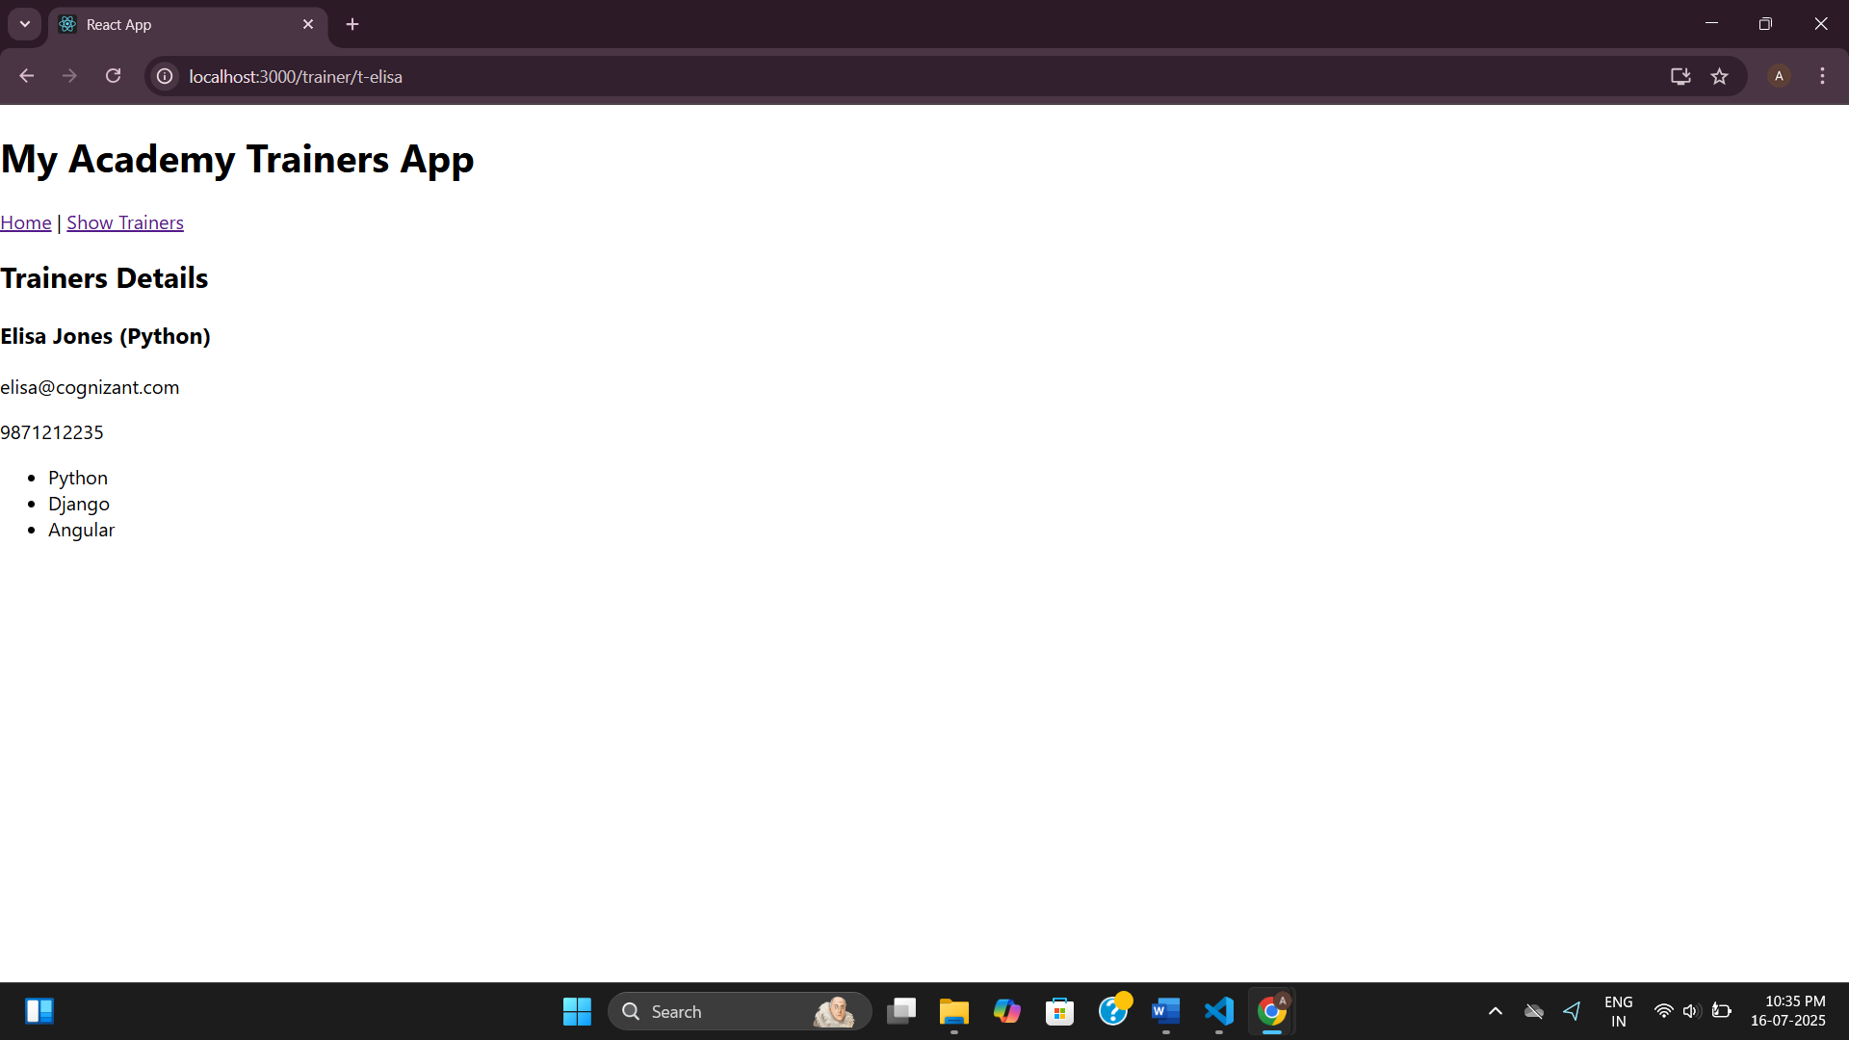

**7.Building a Shopping App Using React Props and Class Components**

**Cart.js**

import React from 'react';

class Cart extends React.Component {

render() {

return (

<tr>

<td>{this.props.itemname}</td>

<td>{this.props.price}</td>

</tr>

);

}

}

export default Cart;

**OnlineShopping.js**

import React from 'react';

import Cart from './Cart';

class OnlineShopping extends React.Component {

render() {

const items = [

{ itemname: 'Laptop', price: 80000 },

{ itemname: 'TV', price: 120000 },

{ itemname: 'Washing Machine', price: 50000 },

{ itemname: 'Mobile', price: 30000 },

{ itemname: 'Fridge', price: 70000 },

];

return (

<div style={{ textAlign: 'center' }}>

<h2 style={{ color: 'green' }}>Items Ordered :</h2>

<table

border="1"

style={{

margin: 'auto',

color: 'seagreen',

borderCollapse: 'collapse',

padding: '8px',

}}

>

<thead>

<tr>

<th>Name</th>

<th>Price</th>

</tr>

</thead>

<tbody>

{items.map((item, index) => (

<Cart key={index} itemname={item.itemname} price={item.price} />

))}

</tbody>

</table>

</div>

);

}

}

export default OnlineShopping;

**App.js**

import React from 'react';

import OnlineShopping from './OnlineShopping';

function App() {

return <OnlineShopping />;

}

export default App;

**index.js**

import React from 'react';

import ReactDOM from 'react-dom';

import App from './App';

ReactDOM.render(<App />, document.getElementById('root'));

**Output:**

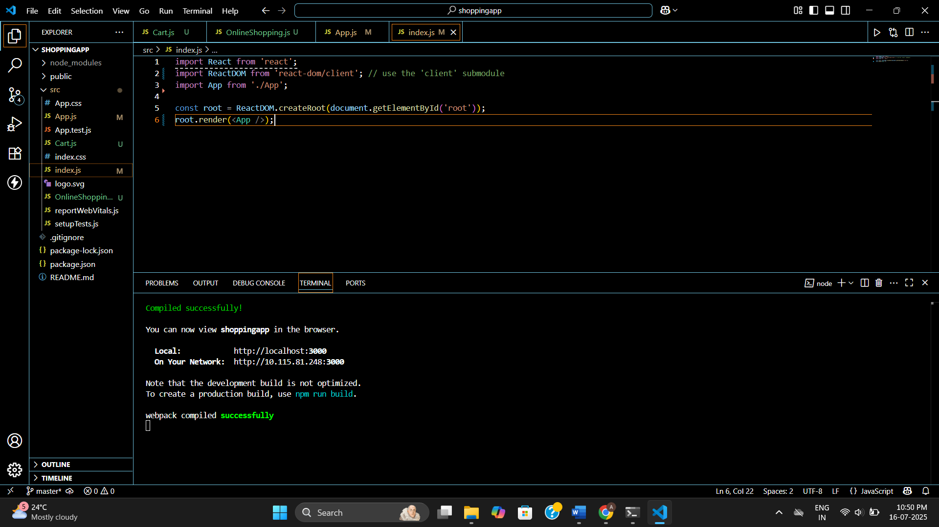

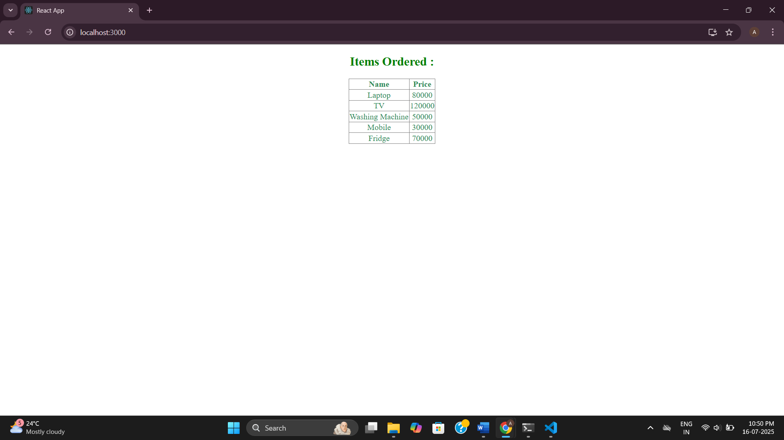

**8.React State Management – Mall Entry/Exit Counter App**

**CountPeople.js**

import React, { Component } from 'react';

class CountPeople extends Component {

constructor(props) {

super(props);

this.state = {

entryCount: 0,

exitCount: 0,

};

}

updateEntry = () => {

this.setState((prevState) => ({

entryCount: prevState.entryCount + 1,

}));

};

updateExit = () => {

this.setState((prevState) => ({

exitCount: prevState.exitCount + 1,

}));

};

render() {

return (

<div style={{ textAlign: 'center', marginTop: '50px' }}>

<button

style={{

backgroundColor: 'lightgreen',

marginRight: '20px',

padding: '8px 16px',

border: '1px solid green',

borderRadius: '5px',

fontWeight: 'bold',

}}

onClick={this.updateEntry}

>

Login

</button>

<span style={{ marginRight: '50px' }}>

{this.state.entryCount} People Entered!!!

</span>

<button

style={{

backgroundColor: 'lightgreen',

marginRight: '20px',

padding: '8px 16px',

border: '1px solid green',

borderRadius: '5px',

fontWeight: 'bold',

}}

onClick={this.updateExit}

>

Exit

</button>

<span>{this.state.exitCount} People Left!!!</span>

</div>

);

}

}

export default CountPeople;

**App.js**

import React from 'react';

import CountPeople from './CountPeople';

function App() {

return (

<div className="App">

<CountPeople />

</div>

);

}

export default App;

**App.css**

.App {

font-family: Arial, sans-serif;

margin-top: 40px;

}

**Output:**

